INTERNATIONAL FEST 2019 “CADUCEUS”
10-16 August
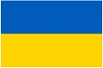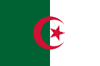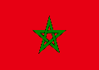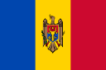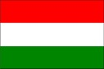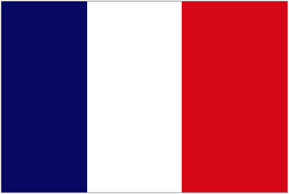

ORGANIZES: GENRES: FEST’S SCHEDULE
10th August – Arrival
11th August – excursions to the main city's tourist attractions with a guide.
12th August – majorette and dance performances.
13th August – band and dance (folk) performances.
14th August – show and vocal performances.
15th August – The ceremony of prizes and diplomas awarding. Gala concert.
16th August – Departure.

VOCALISTS
BANDS
DANCES (MODERN/FOLK)
SHOW
MAJORETTES
FASHION

ПП "ВЕСЕЛИЙ ЖИРАФ"

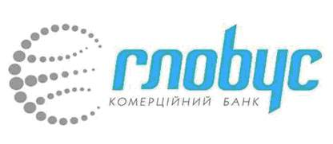
KHARKIV
UKRAINE

POSITION
The main goal of the fest is a friendship between all countries in all over the world.

FEST’S SCHEDULE
10th August – Arrival
11th August – excursions to the main city's tourist attractions with a guide.
12th August – majorette and dance performances.
13th August – band and dance (folk) performances.
14th August – show and vocal performances.
15th August – The ceremony of prizes and diplomas awarding. Gala concert.
16th August – Departure.

GENRES:
VOCALISTS
BANDS
DANCES (MODERN/FOLK)
SHOW
MAJORETTES
FASHION
Location
Kharkiv city, Ukraine

Music
Live, CD or flash card

Participation
- Naming list of the group (surname, first name, birthday, sex) (for collectives)
- Scanned copies of two pages of each passport (for visa support)
- Biography of the group no more than 30 lines (in English) (for collectives)
- Copy of your organization’s certificate (for collectives)
- Two color photos of collective or participant
- Video (dancers) or audio (vocalists) with performance’s numbers
- An application form

All this materials send by e-mail: internationalfestcaduceus@ukr.net

Deadlines:
Applications form, visa copies and flight details will be sent to 15 June.

Free time: you can visit all historical places, museums, theatres, cinemas, quest-rooms, children's entertainment centers or go on excursions to the main city's tourist attractions with a guide.

To the addition every day you will get new information programs with a schedule of a day.

